/* Ashok

Data Profiling Lab

6.24.19*/

1…. Alter table

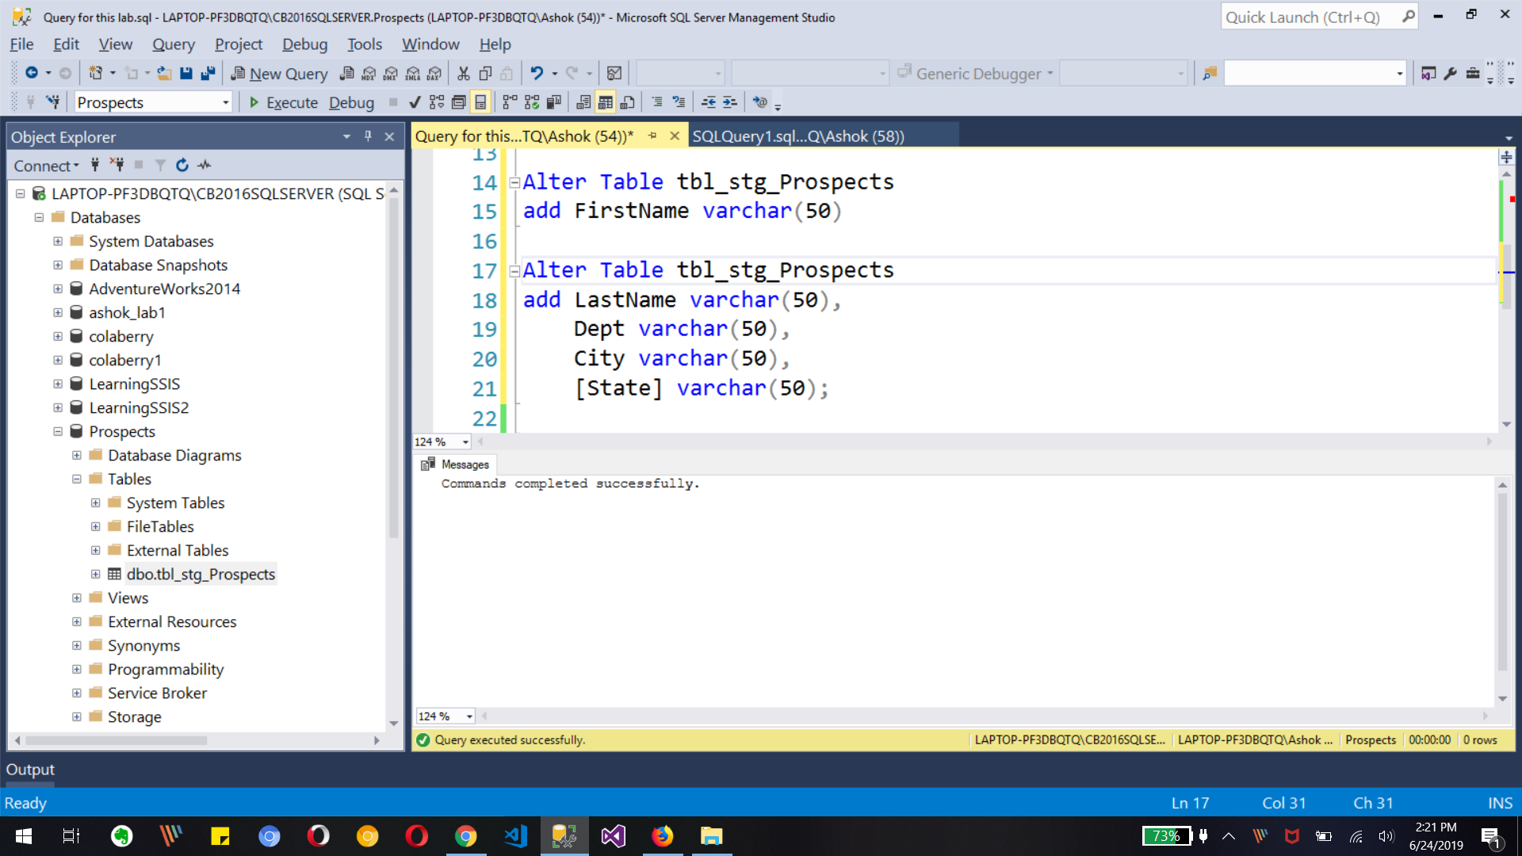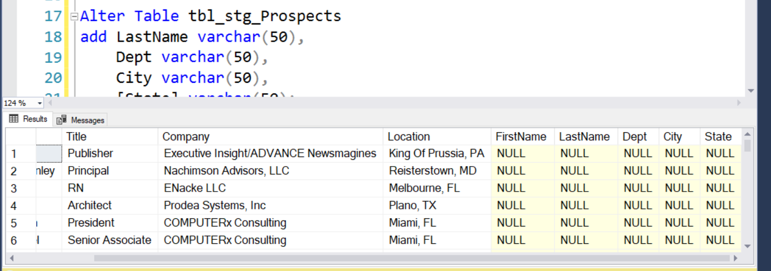

2. Modify Load_Prospects_Staging.dtsx to include the following

a. split the excel columns to populate appropriate information in the newly added fields in tbl_stg_Prospects table.

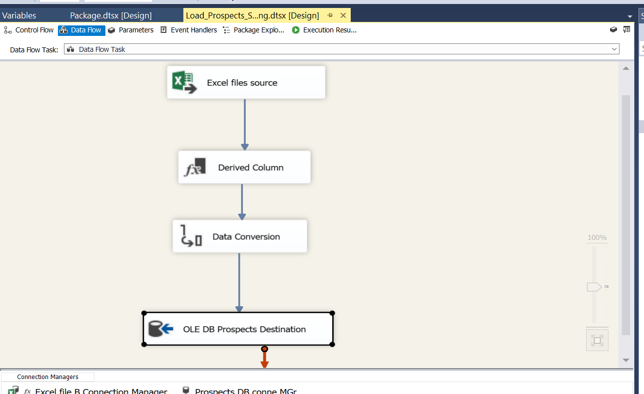

We can use Derived Column to get data for newly added columns to SQL table from Excel file.

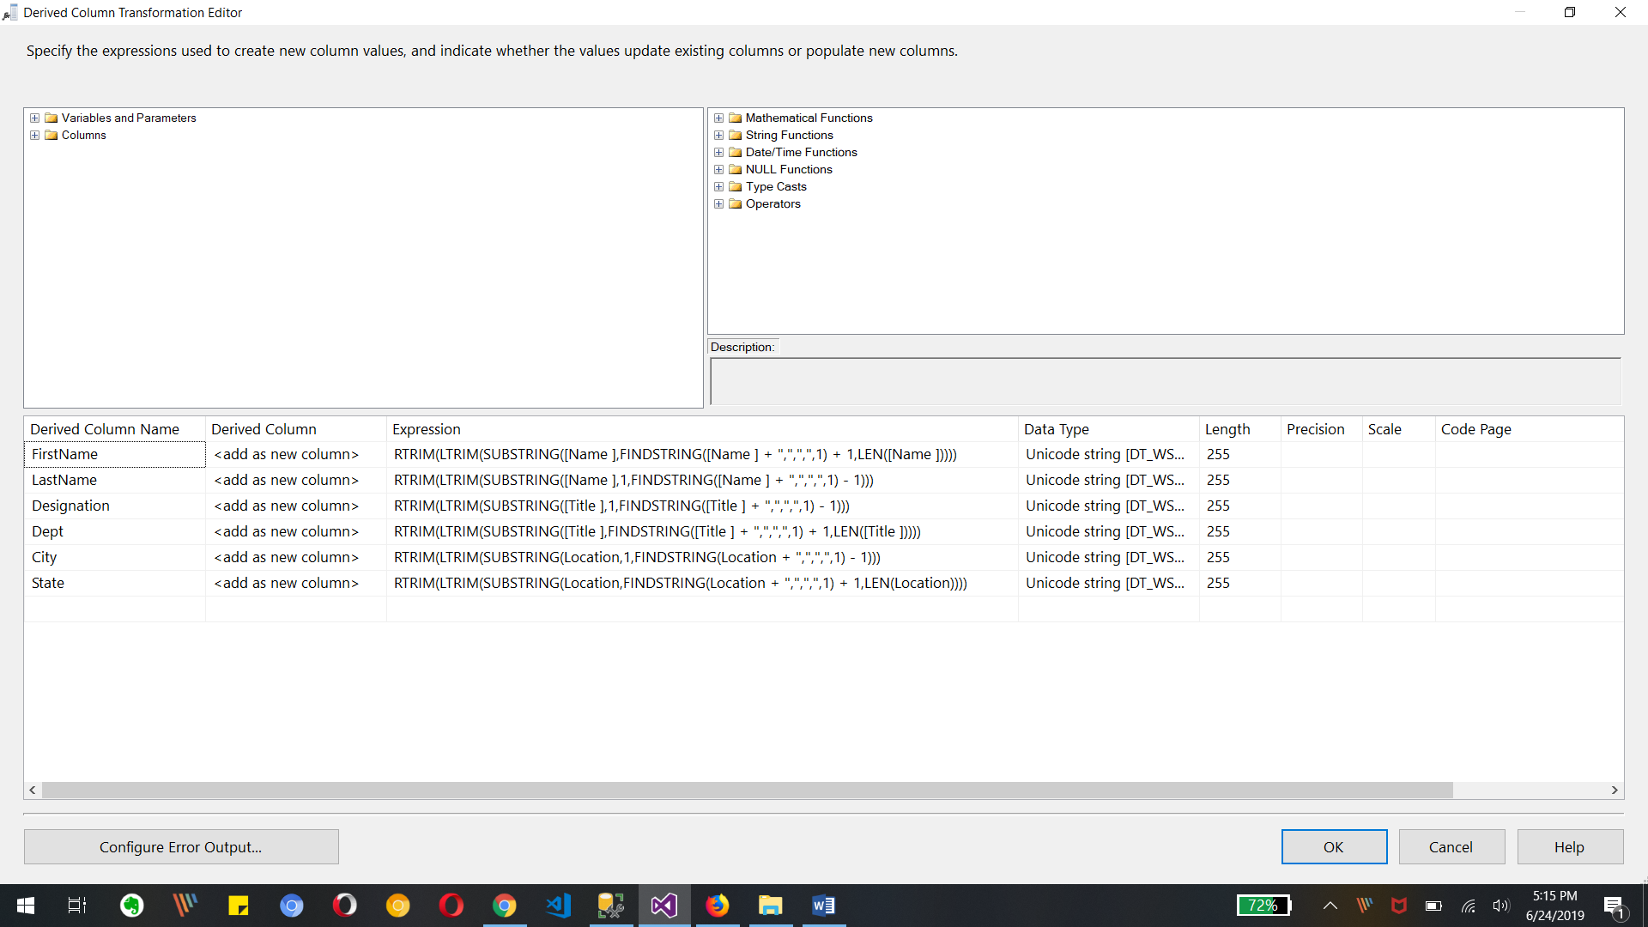

Above Editor with Expression will derive relevant data for newly created columns for table

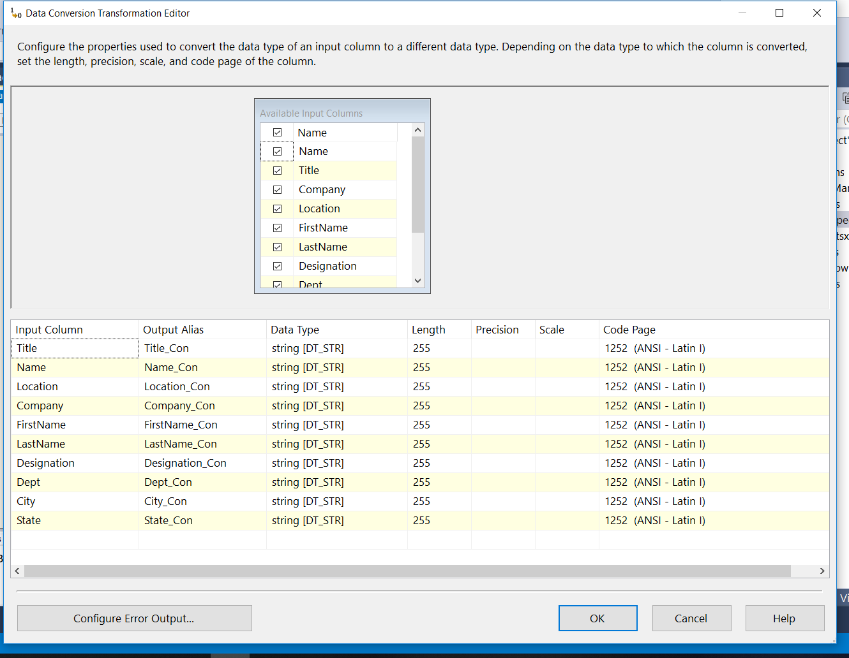

We need to convert data to str for all relevant columns

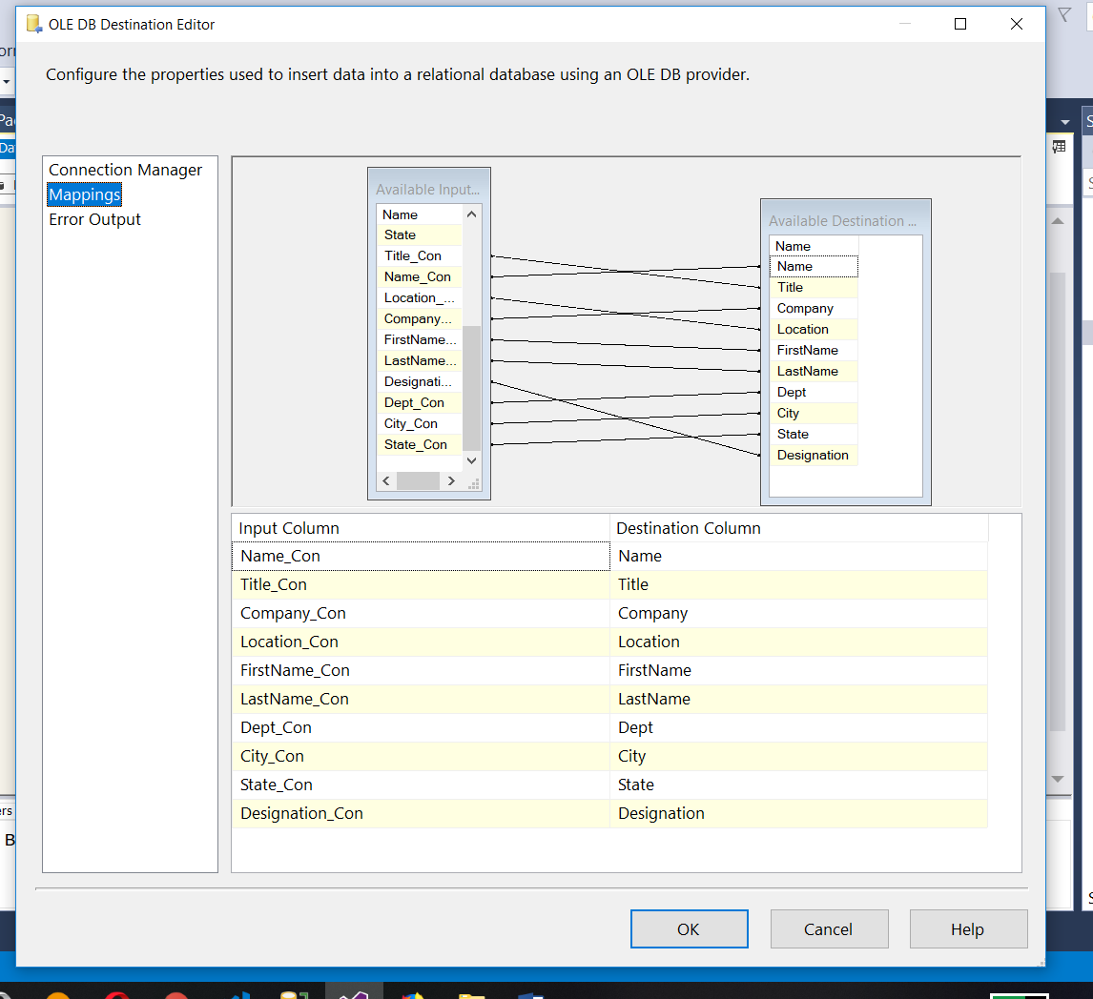

Mapping of Columns from input to destination columns

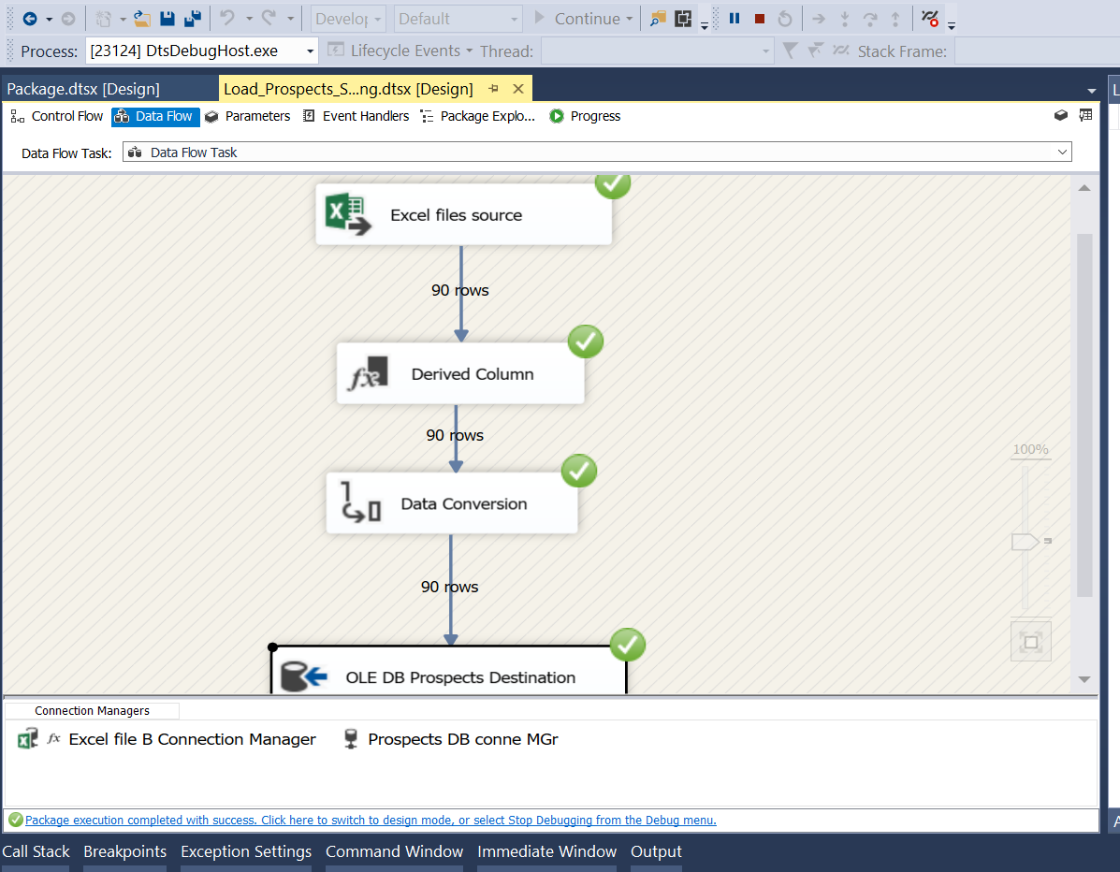

Execution of package for excel to table

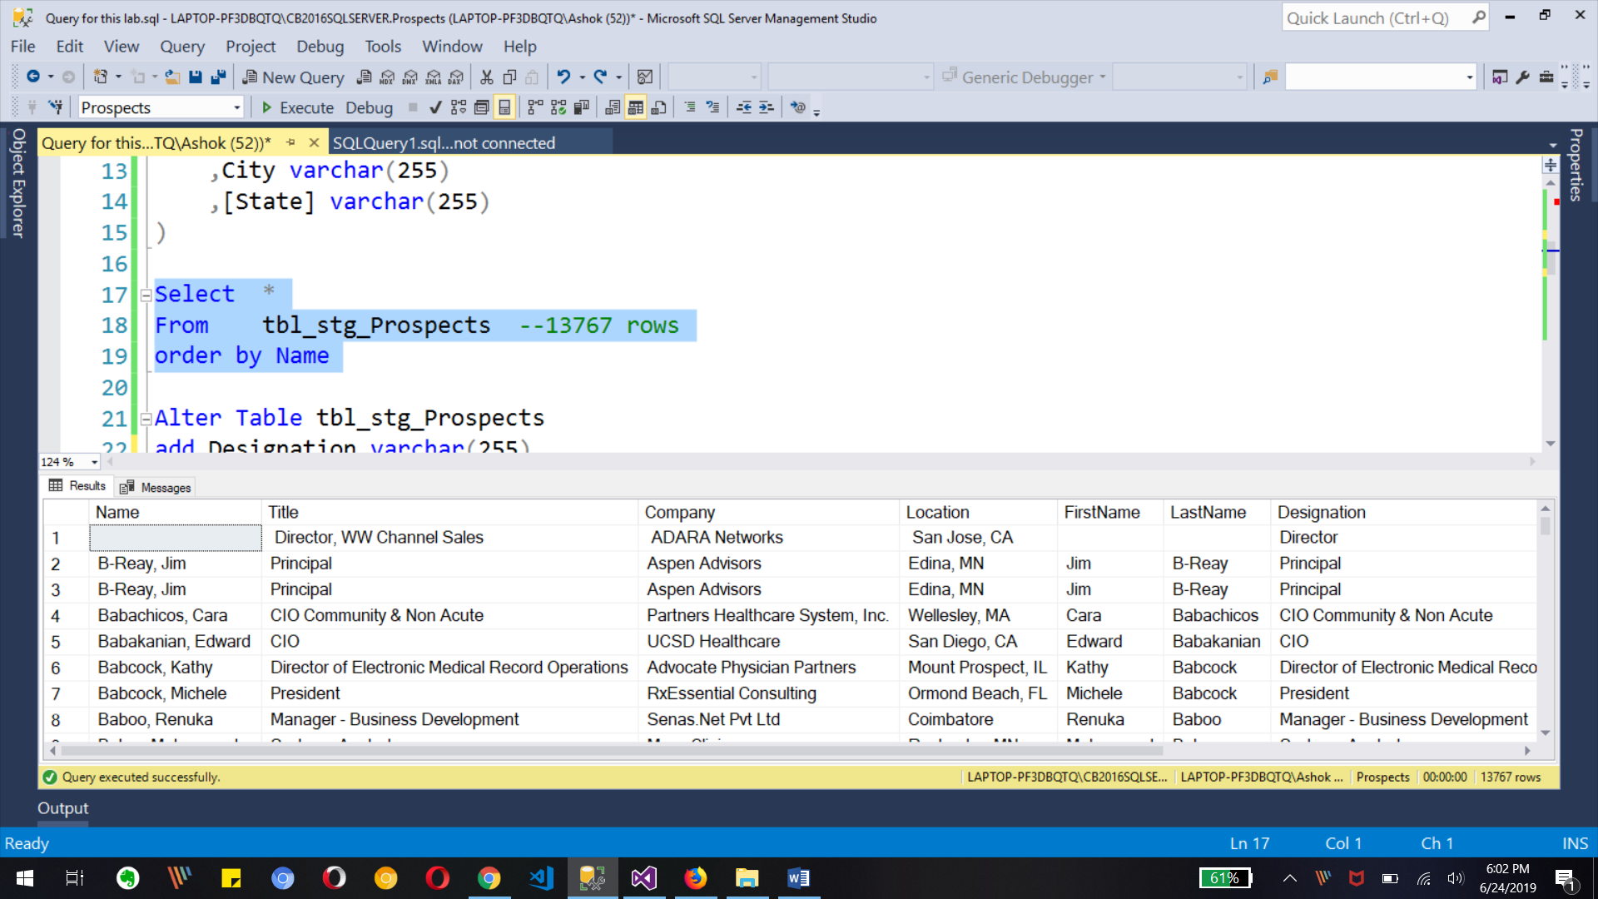

Final Output for table with derived columns

b. filter out records that do not have any value (NULL) in any of the four excel columns

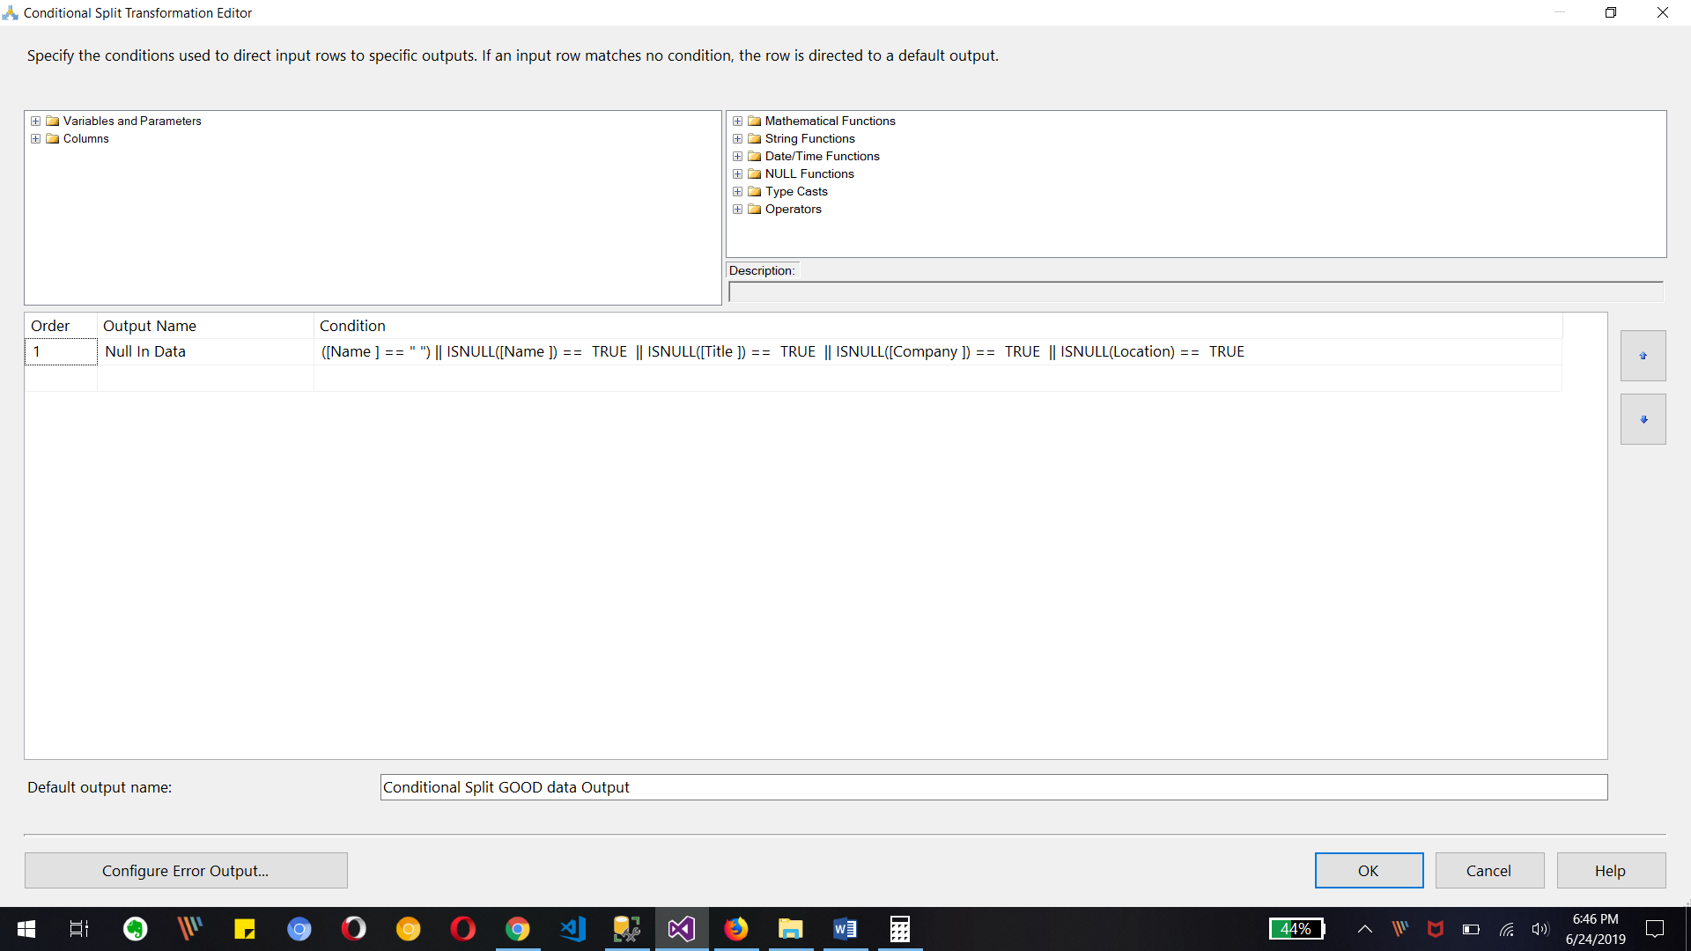

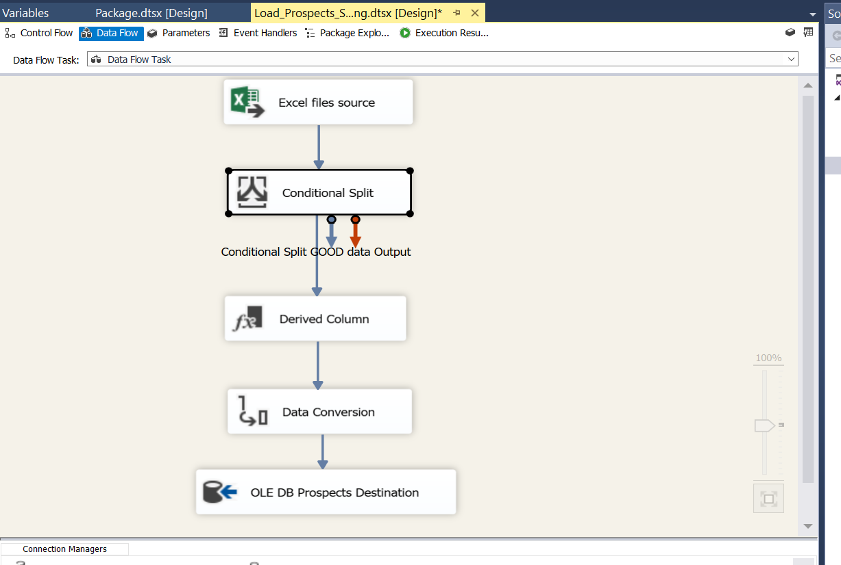

We need to create conditional split task expression as show in image for getting not null data into table and select good data to pass for further process in data flow

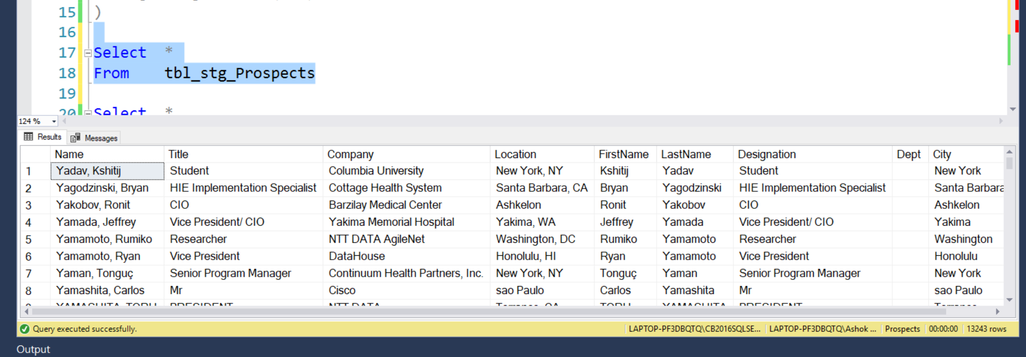

Output in SSMS for tbl_stg_Prospects table as we have not null data with rows then before.

c. check for matching name in tbl_stg_Prospects table and according insert or update the

records in tbl_stg_Prospects table

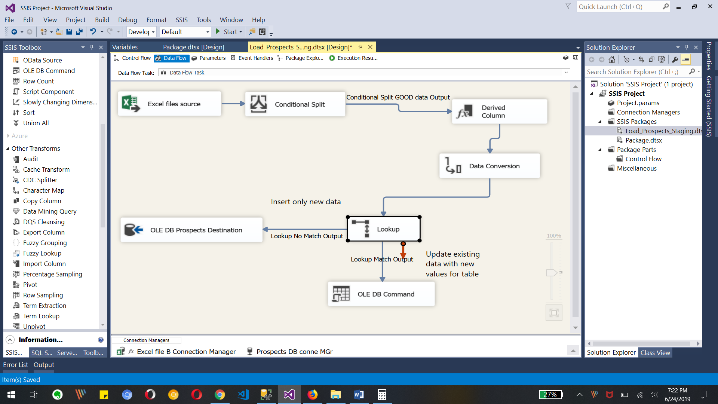

Need to use Look up transformation for checking update to data and insert or update to be done.

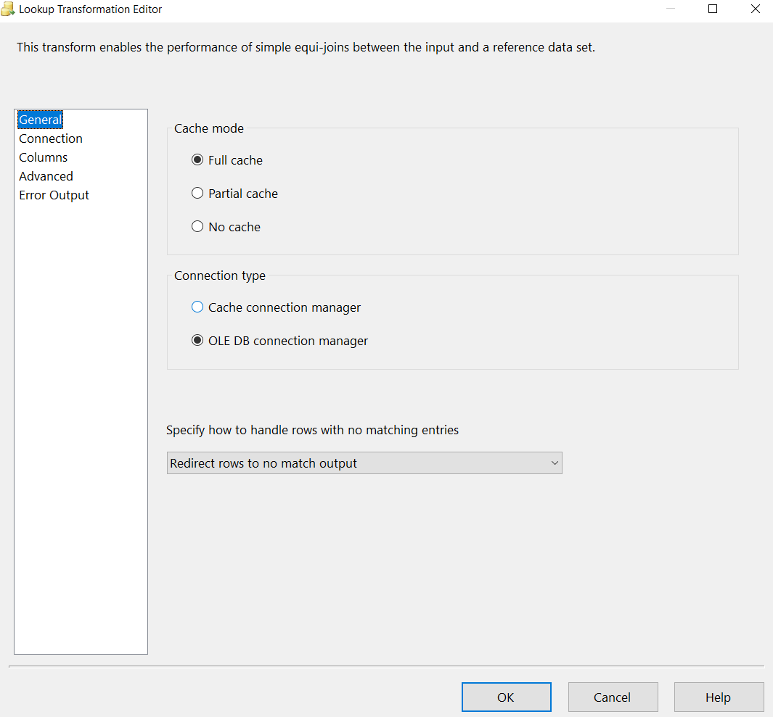

Look up editor for cache and ole db connection with no match data output

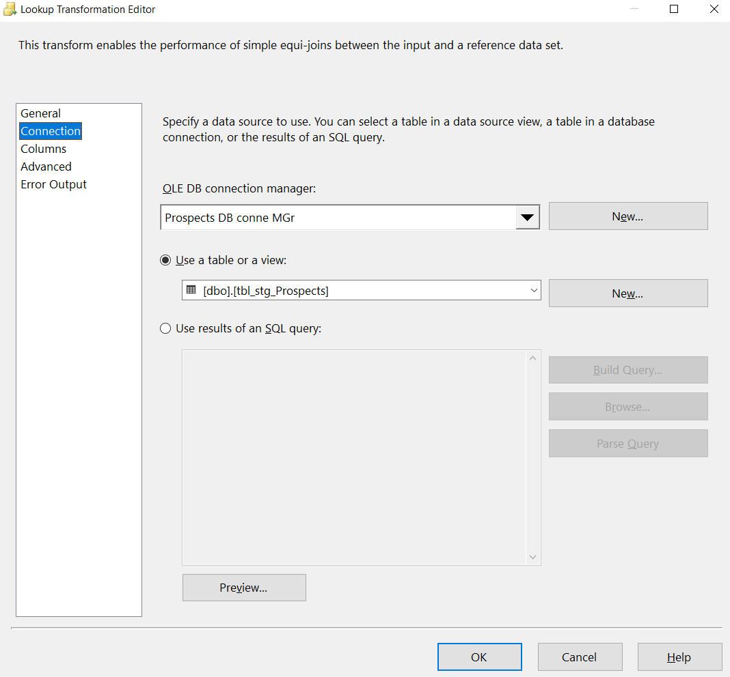

Connection to Database and Table for check data

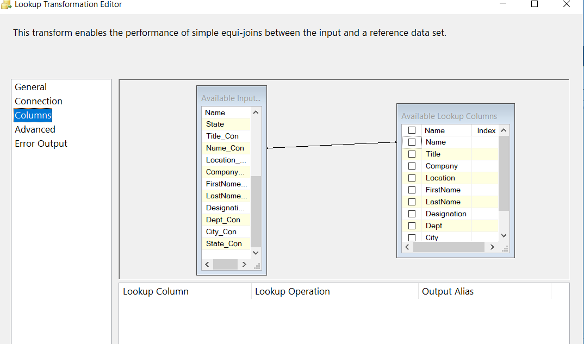

Need to set Name column for look up as any change in data based on it

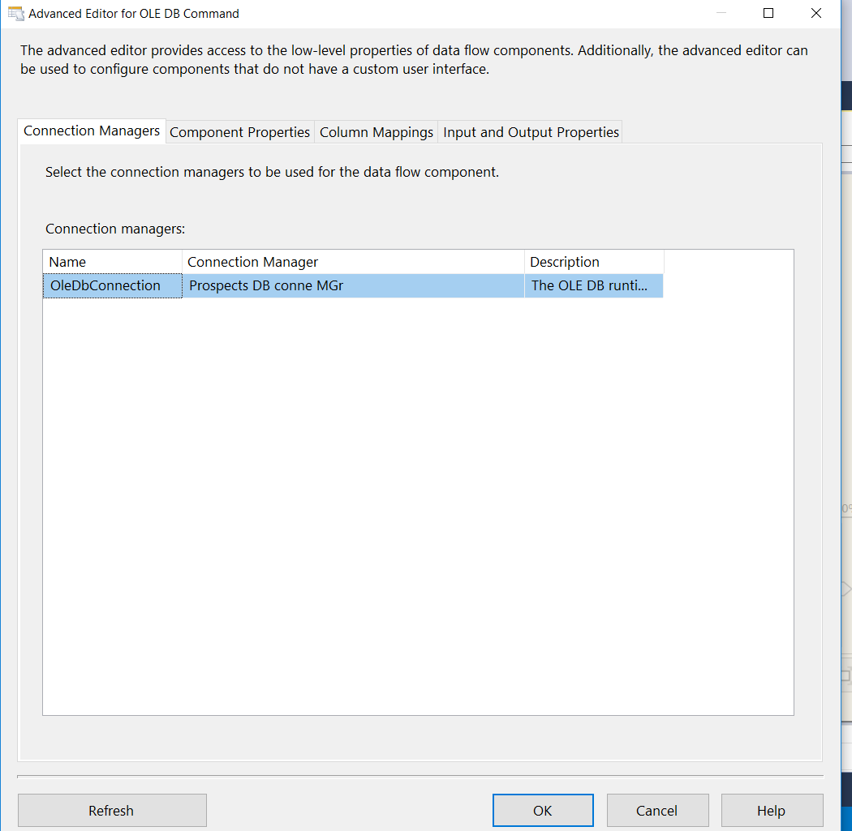

Now we need to get OLE DB Command to update existing record in table

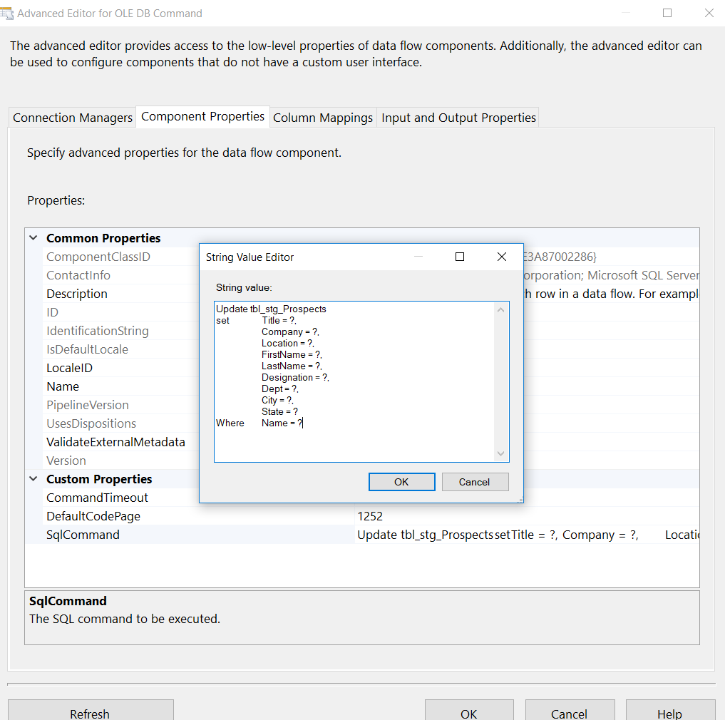

Updating Component property for Sql query to update the record of table

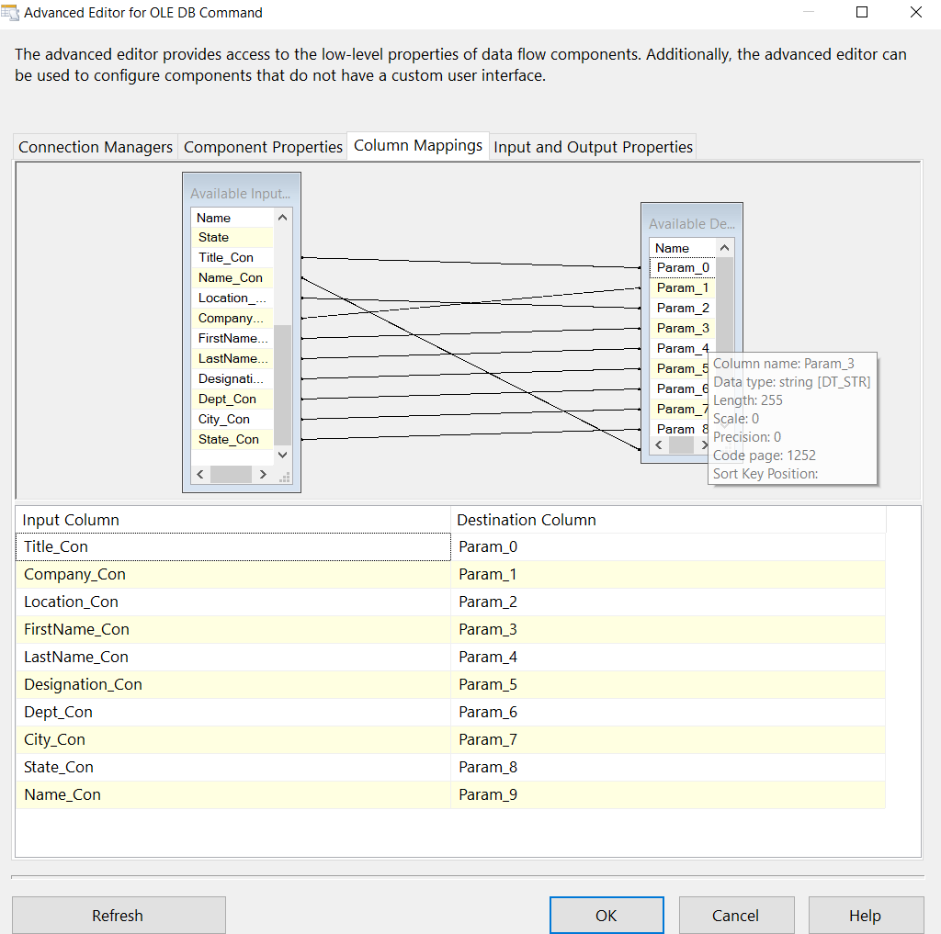

We need to map the columns to parameter as per our SQL query in Component property so We can get data from source to update existing record on table for each name

Test the lookup



I have change one record for city and title and added new record to excel file

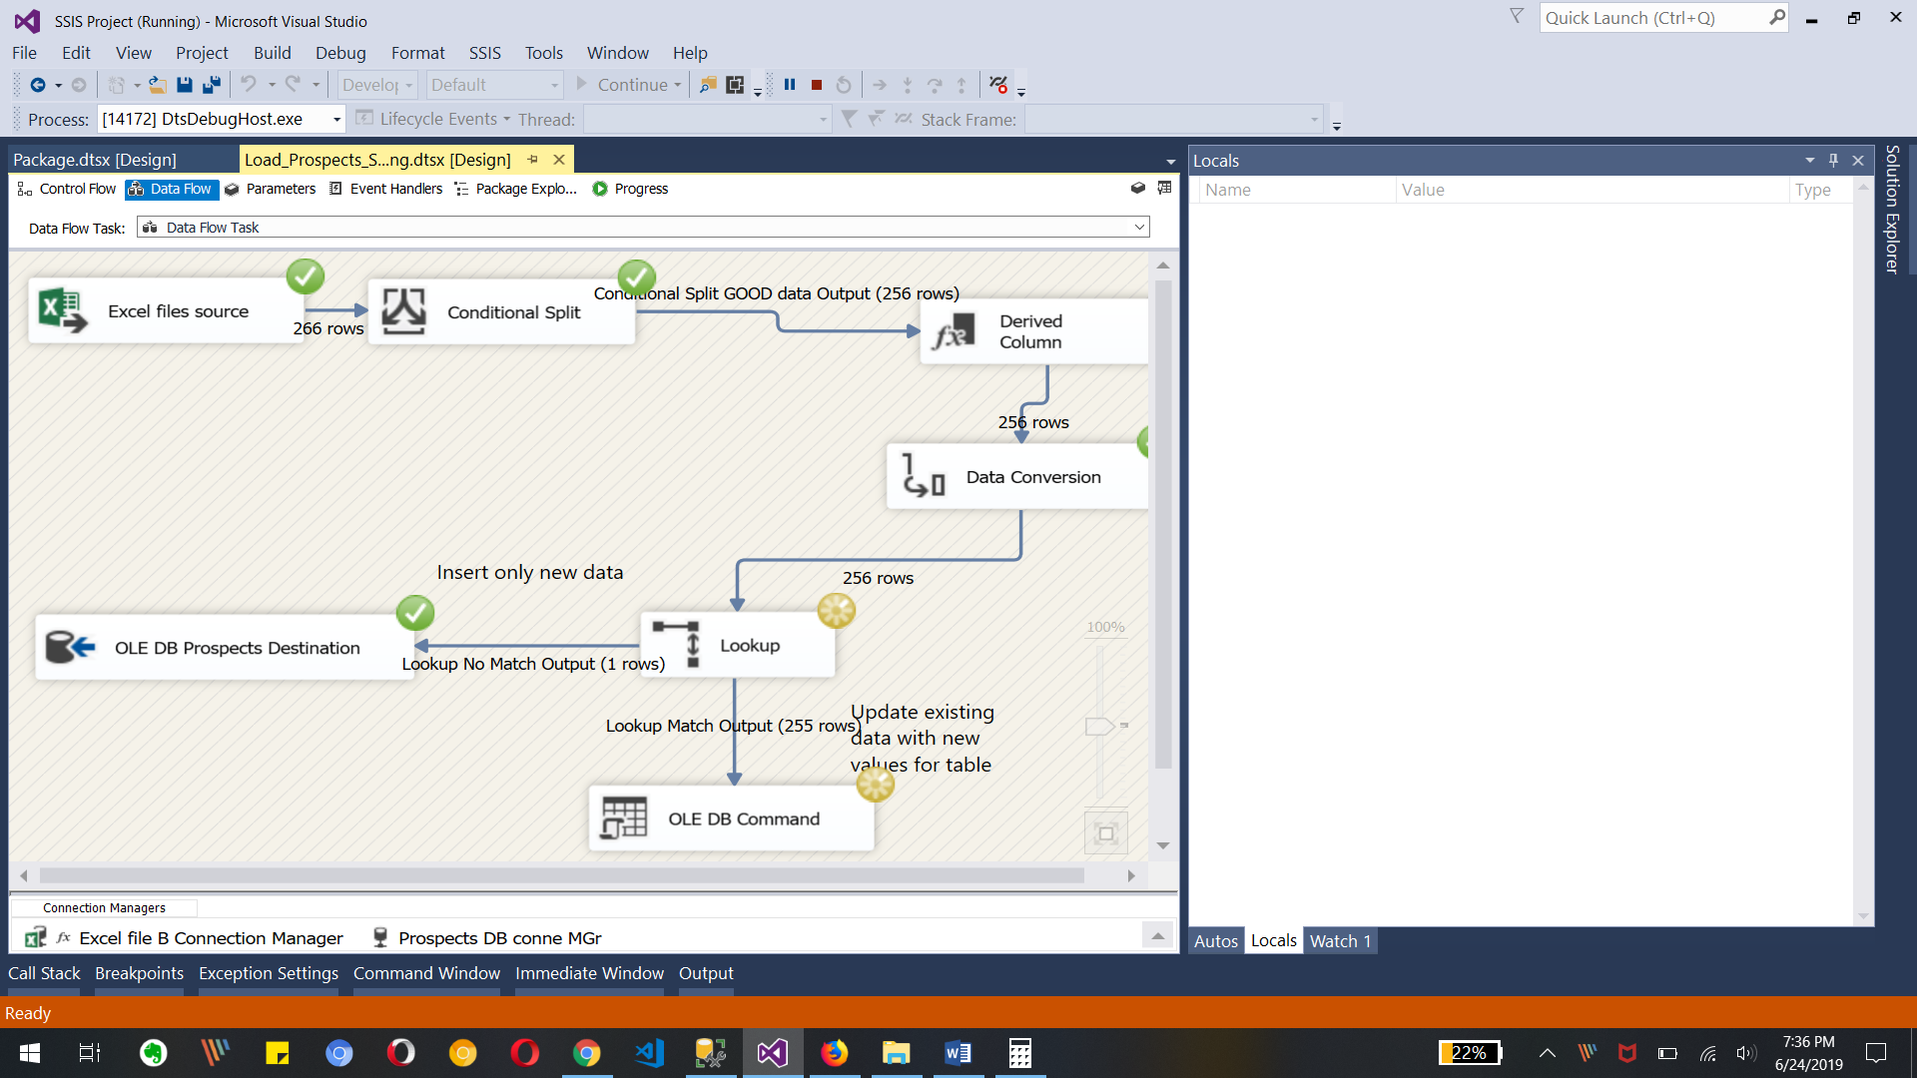

We can see in above image the one new record is inserted to database table.

For Update record it will process for each data rows.

d. Append datetime to the successfully loaded files and move it to Archive folder